19CSE301 : Computer Networks

Lab Sheet 1

AADITHYAN RAJU

AM.EN.U4CSE21301

1. Ping the IP address of another computer.

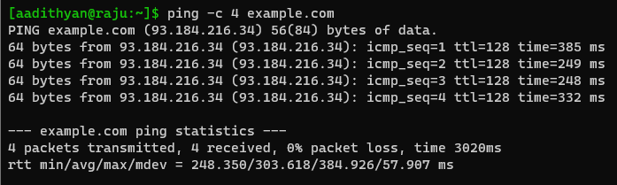

1. Ping the IP address of the default gateway.

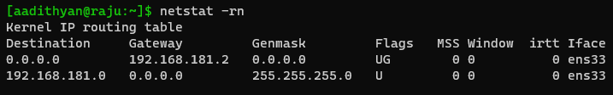

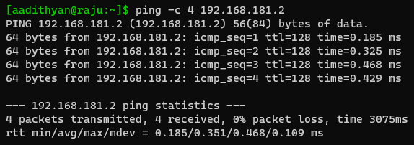

1. Ping the Loopback IP address of this computer (127.0.0.1)

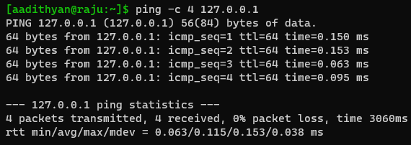

1. Obtain the hostname and IPaddress of amrita.ac.in

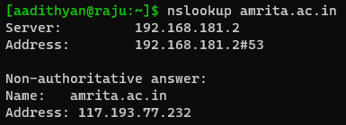

1. Ping to amrita.ac.in and find out how its result differs from ping -c 5 amrita.ac.in

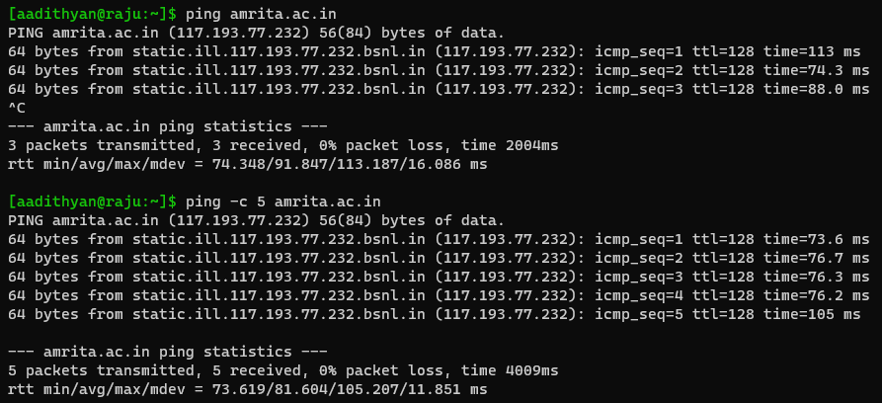

The difference is that, in the first ping we didn’t specify the limit to the number of packets to be sent to the destination number of packets to be sent to the destination.

So, the number of packets transferred will be more when compared to the second ping where we specified the packets limit as 5.

More number of bytes will be transferred when no limit is specified and it keeps on transferring packets.

1. Use nc command to perform the following on your local machine with one terminal as server and other as client.

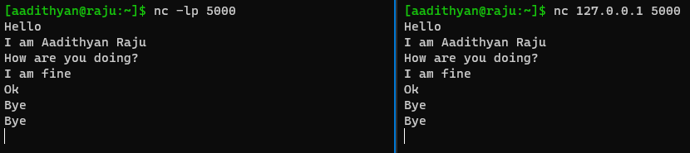

1. Echo a message in server and pass it to the client machine on raising a request

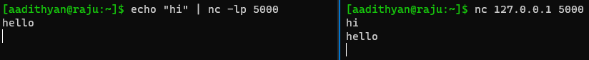

1. Chat with your neighbour. Allow another neighbour to chat with you once the first one is terminated

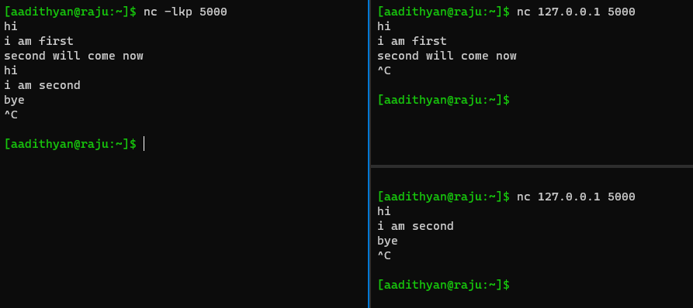

1. Create a chat application such that the client will terminate the connection if no messages being received for 10 seconds.

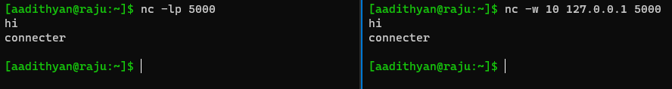

1. List all the files and folders in the client machine at your server.

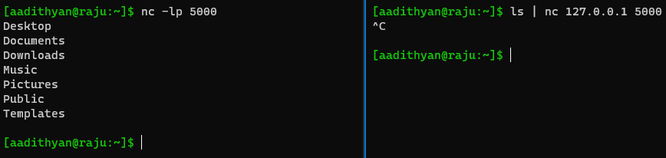

1. Display the contents of any file in your server at the client. (Note: You may create a new file at server if needed)

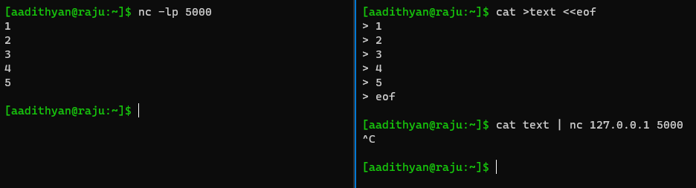

1. Send the man page of ls command in your client machine to the server and server should write it into a file lsman.

